H.T No
Regulations:
A18

Sreenidhi Institute of Science and Technology
(An Autonomous Institution)
Code No: 7AC02 Date: 09-Oct-2020 (FN)

B.Tech I-Year I-Semester External Examination, October - 2020 (Supplementary)
NETWORK ANALYSIS (ECE)

Time: 2 Hours Max.Marks:70

Note: a) No additional answer sheets will be provided.
b) All sub-parts of a question must be answered at one place only, otherwise it will not be valued.
c) Missing data can be assumed suitably.

ANSWER ANY 5 OUT OF 8 QUESTIONS. EACH QUESTION CARRIES 14 MARKS.

1. | a) | State and explain the Kirchhoff’s voltage and current laws with an example. | [7M]
 | b) | Find the value of current for the network shown in the below figure by using Star- delta / delta- star transformation.  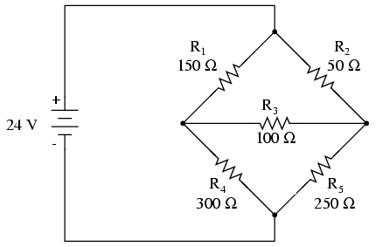 | [7M]
2. | a) | Explain duality in electrical engineering. State the steps followed in finding the dual of a network. | [7M]
 | b) | Determine the voltages at each node by using nodal analysis for the circuit shown in the below figure.  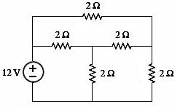 | [7M]
3. | a) | Derive an expression for coefficients of coupling for magnetic circuits. | [7M]
 | b) | If two coils have a mutual inductance of 300µH, calculate the emf induced in one coil when the current in the other coil varies at a rate of 4000A/sec. | [7M]
4. | a) | Define average value, RMS value and form factor for different periodic wave forms. | [7M]
 | b) | Explain the terms:  i) j-notation,  ii) complex form of representation and  iii) polar form of representation. | [7M]
5. | a) | Explain about the concept of series R-L resonant circuit. | [7M]
 | b) | List the different properties of Series and Parallel resonant circuits. | [7M]
6. | a) | State and explain the Norton’s theorem with an example. | [7M]
 | b) | State the maximum power transfer theorem and derive the expression for maximum power transferred to the load. | [7M]
7. | a) | Explain about source transformation technique. | [7M]
 | b) | Write comments on the choice between loop and node methods of analyzing a network. | [7M]
8. | a) | Define and explain the following terms  (i) reactive power (ii) complex power | [7M]
 | b) | Explain the Concept of bandwidth and Q-factor. | [7M]

-- 00 -- 00 –

